Follow the guidelines below in submitting your work.

1. Your homework should have this **cover page** duly filled out by you.
2. Where possible and applicable, your solution should be typed and printed.
3. Show your work in an organized manner. Do not crowd your solution pages.
4. Elaborate on any assumptions made or shortcuts (jumps) taken in your solution.
5. Reference your figures, tables, constants, equations and conversions, used to complete the problem.
6. **Submit ONLY ELECTRONICALLY in Moodle, in only one pdf file (Hard copies are NOT accepted).**

***I declare that this submission is my own, and that no part of it has been copied from another source except where properly acknowledged.***

Student’s signature:_________________________

|  |  |  |  |
| --- | --- | --- | --- |
| Student ID | 200226 | Student Name | Amaan Ahmed Zubairi |
| Course Code | SE 328 | **Course Name** | Mobile Application Development |
| Assignment Number | 1 | **Professor Name** | Dr. George Violettas |
| Date of Submission | Sunday, Feb 13, 2022 | **Instructor Name** |  |
|  |  |  |  |

|  |  |  |  |  |  |  |  |  |  |  |
| --- | --- | --- | --- | --- | --- | --- | --- | --- | --- | --- |
| |  |  |  | | --- | --- | --- | | *Problem* | P1 | Total | | *Mark* |  |  | | *Maximum* | **10** | **10** | | Evaluator’s initials: _______________  Date: _______________ |

|  |  |  |
| --- | --- | --- |
| **Course Learning Outcomes (CLO)** | | **Questions** |
| CLO1 | Design and understand software architecture for large-scale software systems using various architectural styles. | 1 |
| CLO2 | Develop detailed software design using various approaches such as design patterns. | N/A |
| CLO3 | Use sound software metrics to measure and assess the quality of the software. | N/A |
| CLO4 | Express and effectively present a developed software design in a software design document (SDD) for a software project of significant size. | N/A |
| CLO5 | Work effectively as leader/member of a development team to deliver quality software design | N/A |

Follow the slides for Chapter 3, and finalize the project. Make sure your application works fine, and the spinner (drop down menu) has at least three(3) choices.

Then,

create one or more if statements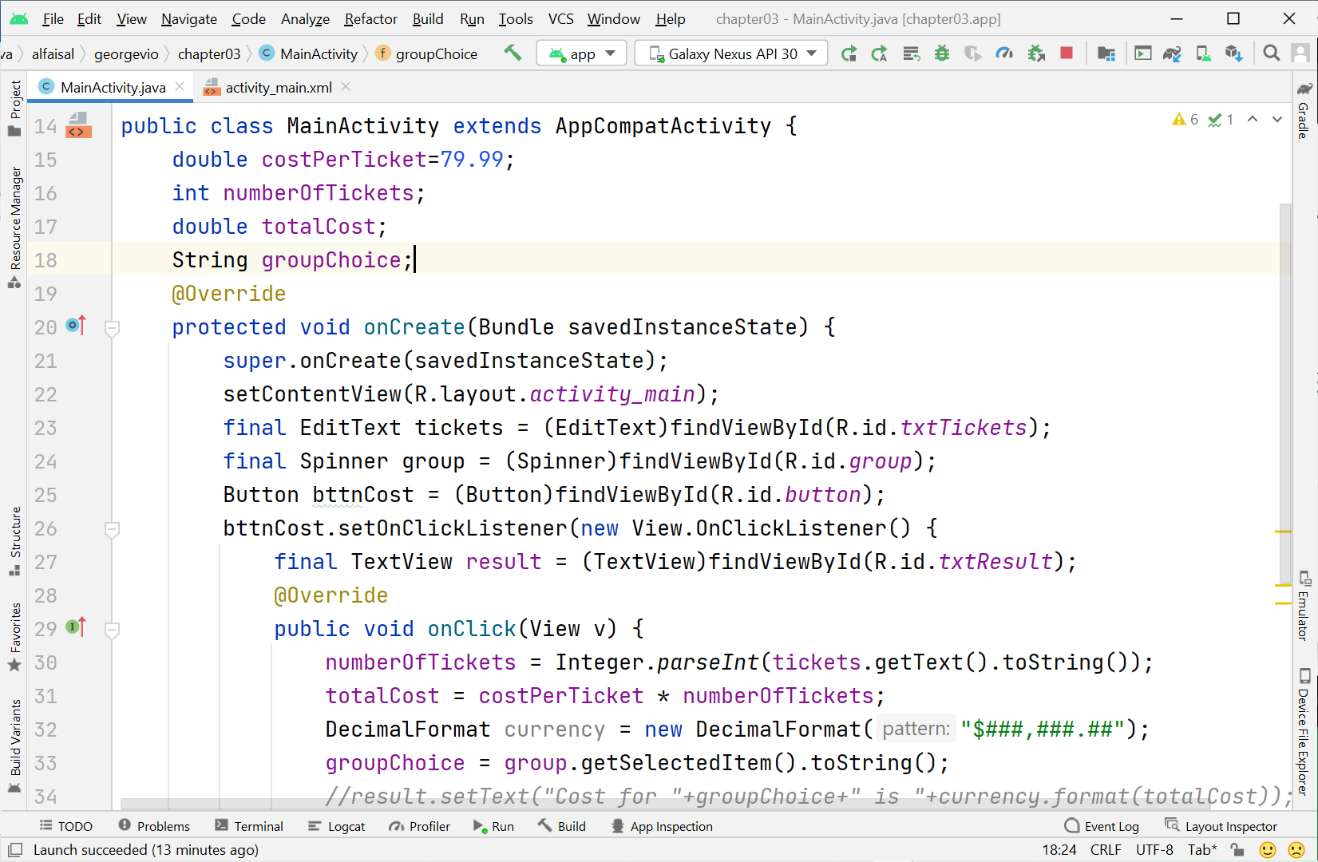 depending on the value of groupChoice (look at line 33 in the figure above), which will calculate a different final price for the totalCost.

Moreover, you have to create different costPerTicketValue variables with values of your choice.

The idea is that the final price depends on the drop-down choice of the user, and the number of tickets.

**MAKE ASSUMPTIONS and state them clearly.**

**DELIVERABLES**:

ONLY ONE pdf file with:

1. Screenshots for the code inserted in MainActivity.
2. Screenshots for the final picture of your application where it calculates difference prices for the SAME number of tickets for different values of the drop-down menu. MAKE SURE THAT THE TITLE OF THE APPLICATION is your name and ID.

***Good luck…***

**Screenshots:**



